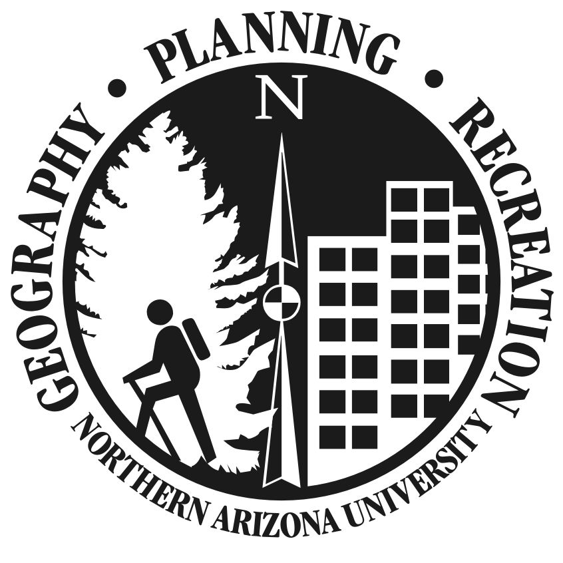

Name: ____________________________________________

ID: _______________________________________________

Degree Requirements for B.S. in Geographic Science and Community Planning
Community Planning & Development Emphasis
(Updated May 2011)

Liberal Studies (35 units total)
Foundations (7)

1a. ENG 105 or 4 or
1b. ENG 101/102 6

2. MAT 114 3

Lab Science (4)

____________________________ _____

Science/Applied Science (3-6units)

____________________________ _____

____________________________ _____

Social and Political Worlds (3-6units)

____________________________ _____

____________________________ _____

Aesthetic and Human Inquiry (3-6 units)

____________________________ _____

____________________________ _____

Cultural Understanding (3-6 units)

____________________________ _____

____________________________ _____

MUST MAX OUT 3 OF 4 (3-6) BLOCKS

Diversity Requirement
Ethnic ____
Global ____

Liberal Studies Elective (3 units) (You take one additional elective course from any liberal studies requirements.)
____________________________ _____

Students must have a 2.5 or better overall grade point average to earn this degree and a C or better in all classes applied to the major. Also, at least 30 units of courses taken for the degree must be upper division, and 30 units must be taken at NAU.

ADDITIONAL ELECTIVE UNITS FROM ANY ACADEMIC AREA FOR 120 TOTAL UNITS

Major Requirements (43 units)
Units Semester Grade
ENG 205: The Academic Writer’s Wkshp. 2 ________ ______
STA 270: Applied Statistics 3 ________ ______
GSP 130: Mapping the World 3 ________ ______
GSP 150: Physical Geography 4 ________ ______
GSP 201: Community Planning & Change 3 ________ ______
GSP 206: Public Participation & Comm. 3 ________ ______
GSP 240: World Geography West 3 ________ ______
OR GSP 241: World Geography East
GSP 303: Comm. Design and Preservation 3 ________ ______
GSP 371: Urban Realm: Context and Lsp. 3 ________ ______
GSP 375W: Community & Global Analysis 3 ________ ______
GSP 432: GIS for Urban Environments 3 ________ ______

6 experiential learning units from the following selected with advisor consent:

GSP 389: Cooperative Education 1-12 ________ ______
GSP 408: Internship 1-12 ________ ______
GSP 485: Undergraduate Research 1-6 ________ ______
GSP 497: Independent Study 1-6 ________ ______

Capstone Requirement:

GSP 405C: Senior Professional Project 4 ________ ______

Emphasis Requirements (18 units)

GSP 276: Planning for Sustainable Tourism 3 ________ ______
GSP 401: Permitting & Review Process 2 ________ ______
GSP 402: Environ. Impact Statements 3 ________ ______
GSP 406: Data Analysis & Digital Comm. 3 ________ ______
GSP 421: Land Use Planning Law & Ethics 3 ________ ______

4 Additional units in Community Planning or related fields selected with advisor consent.

_____________________________________ _____ __________ ________

_____________________________________ _____ __________ ________

_____________________________________ _____ __________ ________

